PROJECT REPORT

**Festival Event Registration System (FERS)**

**ABSTRACT:**

Festival Event Registration system (FERS) Admin Portal is a web application developed in JAVA and SQL. This is an online event Registration system software project that serves the functionality of an event manager. It allows user to select from a list of events. Once the user enters an event type, the system then allows the user to register for an event. If the user wants to cancel the registration he can cancel the present event and can register to another event. This simple multitier application serves as the Admin portal for the Portal Administrator to manage the database. Web pages are used to provide information about the different tourist attractions in both the North and South Towns.

**INTRODUCTION:**

A city formed from the merger of two smaller towns (i.e. North Town and South Town). North Town is urban and South Town is rural. The New Codington River separates the towns. The city elements will be interwoven throughout the course activities, coding exercises and the simulation.

The Festival Event Registration system (FERS) Admin Portal is used to connect to the database. This simple multi-tier application serves as the Admin portal for the Portal Administrator to manage the database. Web pages are used to provide information about the different tourist attractions in both the North and South Towns.

A festival has been organized to celebrate the union of the North and South Towns in New Codington. This application is used create a multi-Tier Enterprise application that will use a web-based search tool to find available attractions and allow visitors to register for those attractions.

**REQUIREMENT SPECIFICATION:**

Operating System: Microsoft® Windows® 7/8/10 (32- or 64-bit).

RAM: 4GB minimum, 8 GB recommended.

Software’s used: Eclipse, Spring Tool Suite(STS), Apache TOMCAT, MySQL

**ARCHITECTURE DESIGN:**

Sequence Diagrams:

1. Visitor Registration

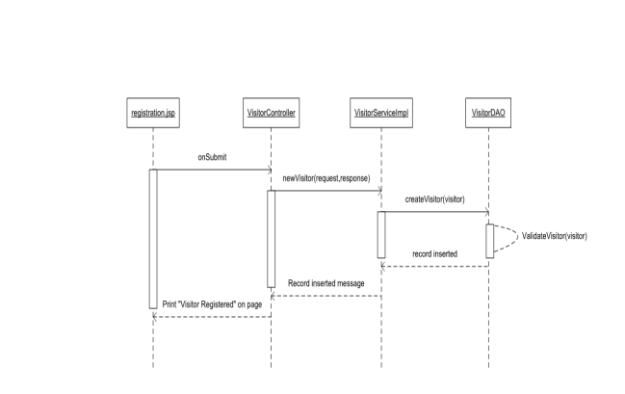

2.) Login Visitor

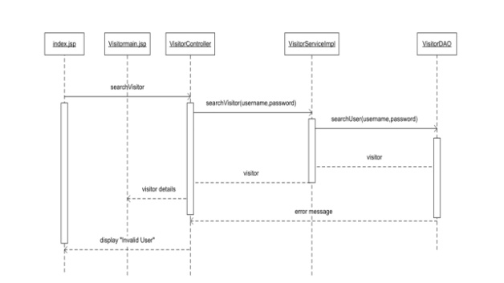

3.) Update Visitor

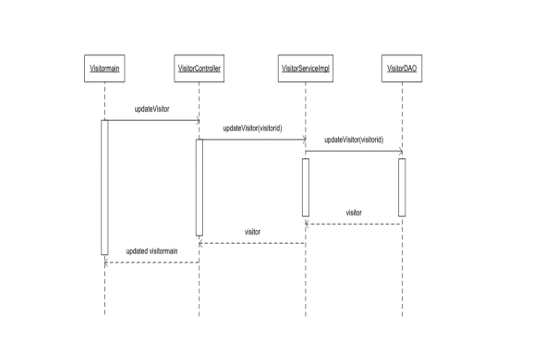

4.) Event Registration

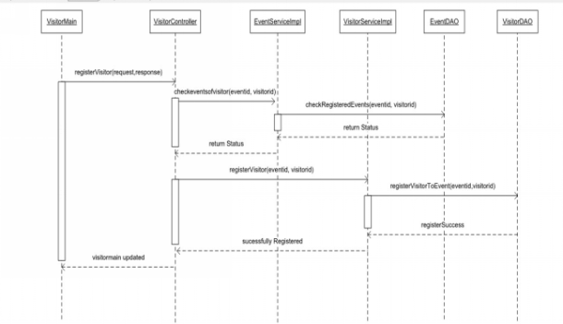

5.) Un-register from Event

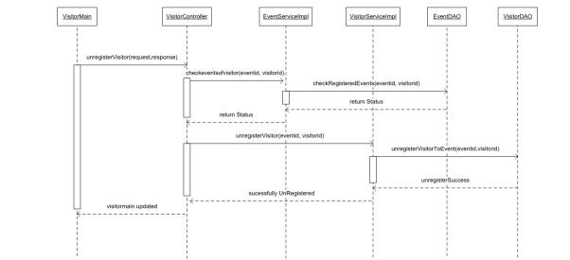

**CONCLUSION AND FUTURE WORK:**

We have implemented this project in Monolithic architectural design which is working successfully with real time data. In future Scope we will implement this project using micro services for each and every module as an independent service.

**REFERENCES:**

* <https://blog.capterra.com/8-free-and-open-source-event-registration-software/>
* <https://medium.com/hubilo-officil-blog/12-online-platforms-to-get-your-event-registrations-in-place-de7ab9c4e577>
* <https://spring.io/>
* <https://www.google.com/search?q=html+and+css+projects&oq=html+and+css&aqs=chrome.1.69i57j0l5.4614j0j7&sourceid=chrome&ie=UTF-8>
* <https://www.google.com/search?q=mysql&oq=mysql&aqs=chrome.0.69i59l2j69i65j69i60j0l2.1414j0j7&sourceid=chrome&ie=UTF-8>